A Report on
MINI CHESS GAME
For
Micro Project of Third Year, (TY Sem-V)
Project Work in
Bachelor of Engineering
in
ELECTRONICS & TELECOMMUNICATION ENGINEERING
by
2. B-549 Rutuja Thorat

Under the guidance of
Dr. Aboli Khedekar


UNIVERSITY OF MUMBAI
A. Y. 2026-27

ABSTRACT
MINI CHESS is a Java-based desktop chess game developed using Java Swing. The project provides an interactive graphical interface where two players can play chess on an 8×8 virtual chessboard. The system implements the basic movement rules of all chess pieces along with important chess features such as turn management, legal move validation, king safety, check, checkmate, stalemate, castling, en passant, pawn promotion, move highlighting, and undo functionality.
The main objective of the project is to develop a simple and user-friendly chess application while demonstrating important concepts of Java programming, object-oriented programming, GUI development, event handling, arrays, data structures, and logical problem solving. The chessboard is represented using a two-dimensional array, while Java Swing components such as JFrame, JButton, and JTextArea are used to create the graphical interface. The project provides practical experience in developing an interactive desktop application and implementing complex rule-based logic using Java.

INDEX
 | CONTENTS
 | Abstract | …………………………………………………………………... |  | ii
1. | Introduction ………………………………………………………………….  - Overview  - Objectives |  |  | 1
2. | Problem Definition…………………………………………………………….  2.1 Problem Statement  2.2 Challenges |  |  | 2-3
3. | Methodology …………………………………………………………..  3.1 System Design  3.2 Board Representation  3.3 Move Validation Strategy  3.4 Special Rules Handling  3.5 Game Flow  3.6 State Management |  |  | 4-12
4. | Implementation Code ……………………………………………………… |  |  | 13-44
5. | Graphical User Interface……………………………………………………..  5.1 GUI Design  5.2 Features |  |  | 45-47
6. | Results and Discussion……………………………………...………………...  6.1 Result  6.2 Discussion |  |  | 48
7. | Conclusions & Future Scope …………………………………………………………………. |  |  | 49
 | References |  | …………………………………………………………………... | 50

CHAPTER 1
1. INTRODUCTION
1.1 Overview
Chess is a strategic board game played between two players on an 8×8 board. Each player controls sixteen pieces, including a king, queen, rooks, bishops, knights, and pawns. Every chess piece has its own movement rules, and players must follow these rules while attempting to protect their king and capture the opponent's pieces.
Chess is a desktop-based chess application developed using the Java programming language and Java Swing. The project converts the traditional chess game into an interactive software application.
The application provides an 8×8 graphical chessboard where players can select pieces and move them using the mouse. The system checks whether the selected movement is legal before updating the board.
The project also implements advanced chess rules such as castling, en passant, pawn promotion, check, checkmate, and stalemate. An undo facility is also provided to restore a previous game state.
The project demonstrates the practical implementation of programming concepts through a real-world game application.

1.2 Objectives
The main objectives of the project are:
- To develop a chess game using Java programming.
- To create an interactive graphical chessboard using Java Swing.
- To implement movement rules for all chess pieces.
- To validate legal and illegal chess moves.
- To maintain proper player turns.
- To implement king safety and check detection.
- To detect checkmate and stalemate conditions.
- To implement special chess rules such as castling and en passant.
- To implement pawn promotion.
- To provide move highlighting for the selected piece.
- To provide an undo facility
CHAPTER 2
2. Problem Definition
2.1 Problem Statement

Traditional chess requires a physical chessboard and chess pieces. Managing the rules manually can sometimes result in incorrect moves or difficulty in maintaining the current game state.
The purpose of this project is to develop a Java Swing-based chess application that provides a digital chessboard and automatically handles important chess rules.
The system should allow two players to interact with the chessboard, select pieces, identify legal moves, execute valid moves, and maintain the correct game state.
The application must also prevent illegal moves and identify important game conditions such as check, checkmate, and stalemate.
2.2 Challenges
During the development of the Chess Game application, several challenges were considered:
1. Implementing Piece Movement
Each chess piece has different movement rules. The program must correctly handle pawn, rook, knight, bishop, queen, and king movement.
2. Legal Move Validation
The application must distinguish between legal and illegal moves. A move should only be executed when it satisfies the movement rules of the selected piece.

3. King Safety
A player cannot make a move that leaves their own king under attack. Therefore, the program needs to check the resulting board position before accepting a move.
4. Special Chess Rules
Implementing castling, en passant, and pawn promotion requires additional conditions and game-state information.
5. Check and Checkmate
The program needs to identify when a king is under attack and determine whether the player has any legal moves remaining.
6. Game State Management
The previous board state must be stored so that the user can use the undo function.
7. Graphical User Interface
The board must be displayed clearly while also allowing users to select pieces and destinations through mouse clicks.
8. Turn Management
The program must ensure that White and Black players move alternately and that one player cannot move the opponent's pieces.

CHAPTER 3
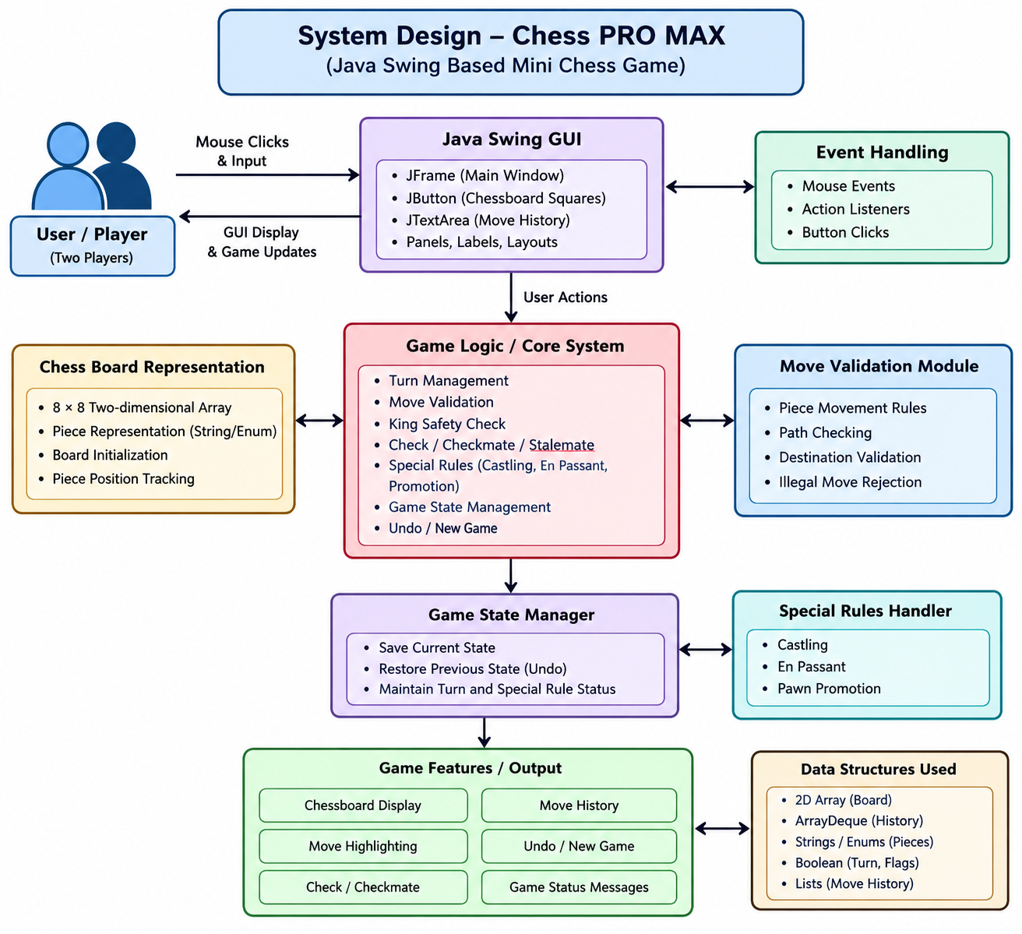
3. SYSTEM DESIGN AND METHODOLO

The player interacts with the Java Swing interface. The chessboard module maintains the current positions of all pieces. The move validation module checks whether a selected move is valid. King safety is checked before a move is finalized. Special chess rules are handled separately, while the game-state module maintains previous positions for undo functionality.

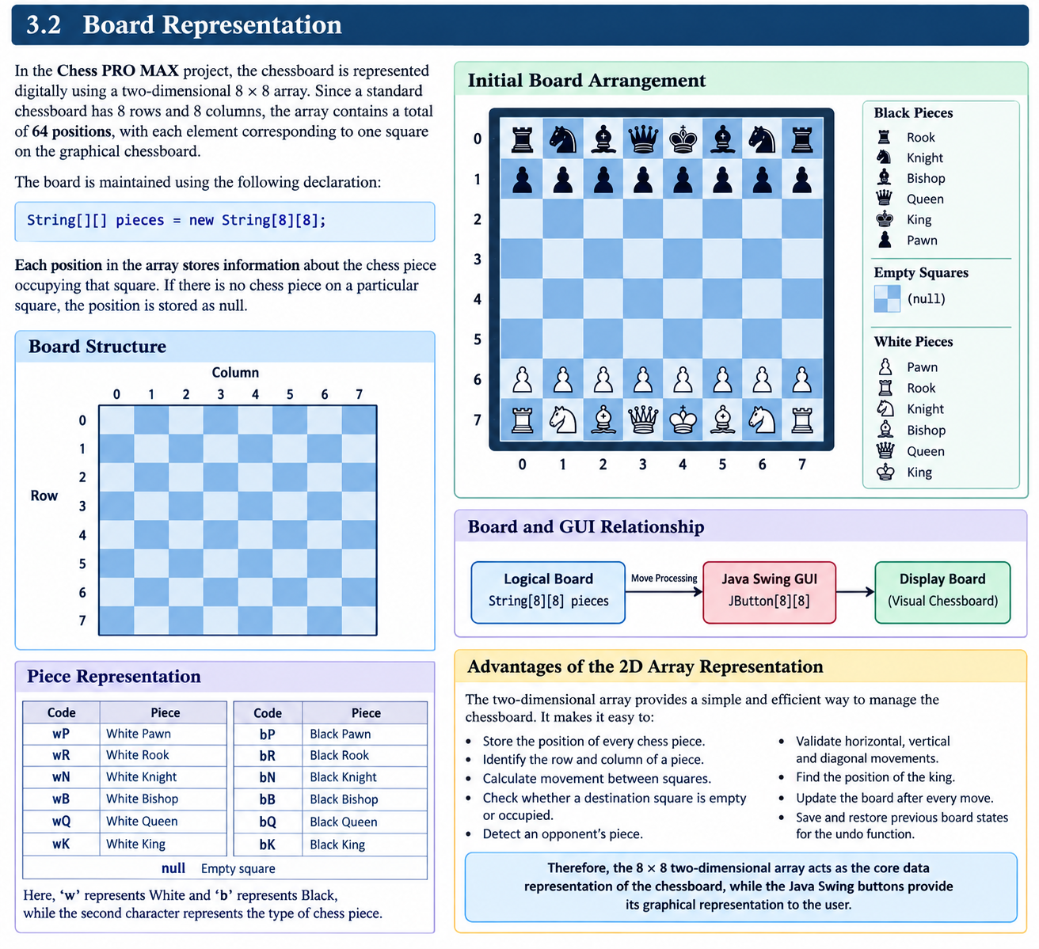
3.2 Board Representation
3.3 Move Validation Strategy
In Chess PRO MAX, move validation is divided into two levels: Basic Validation and Advanced Validation. Basic validation checks whether the selected move follows the normal movement rules of the chess piece, while advanced validation checks game conditions such as king safety and special chess rules.
3.3 1 Basic Validation
Basic validation checks the fundamental conditions before a chess move is executed
- Selected Piece Validation
First, the program checks whether the selected square contains a chess piece. If the selected square is empty, no move is performed.
- Player Turn Validation
The program checks whether the selected piece belongs to the player whose turn it is. This prevents a player from moving the opponent's pieces.
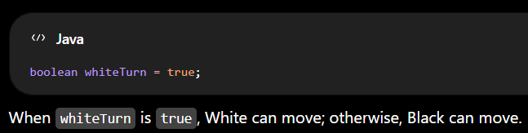
- Board Boundary Validation
The destination square must be inside the 8 × 8 chessboard. The valid row and column values are from 0 to 7
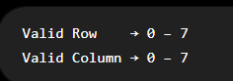

- Piece Movement Validation
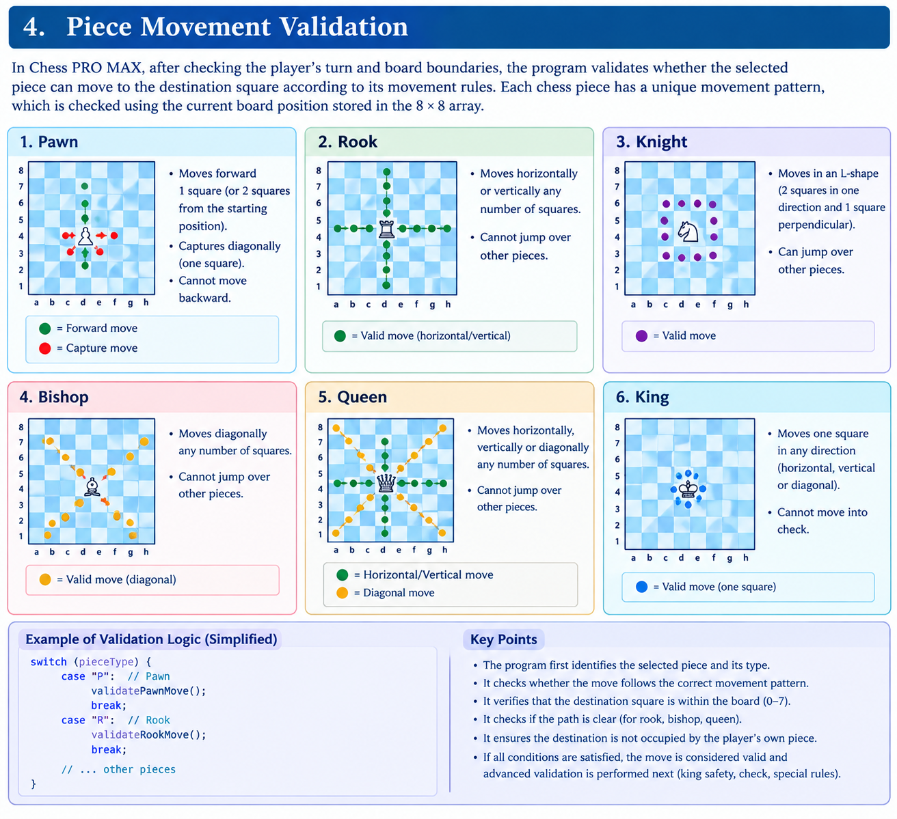

5 Destination Validation
The program checks the destination square before moving the piece.
- If the square is empty, the move may be allowed.
- If it contains an opponent's piece, the piece may be captured.
- If it contains the player's own piece, the move is rejected.

6. Path Validation
For pieces that cannot jump over other pieces, the program checks the squares between the starting and destination positions.
This mainly applies to:
- Rook
- Bishop
- Queen
The Knight does not require path checking because it can jump over other pieces.

7. Basic Validation Flow
Select Piece
↓
Is Piece Present?
↓
Check Player Turn
↓
Check Board Boundary
↓
Check Piece Movement
↓
Check Destination
↓
Check Path
↓
Basic Move Valid?
┌──────┴──────┐
NO YES
↓ ↓
Reject Move Proceed to
Advanced Validation

  - Special Rules Handling
application supports important special chess rules.

Castling
Castling is a special move involving the king and a rook. The program maintains flags to track whether the king or rook has already moved.
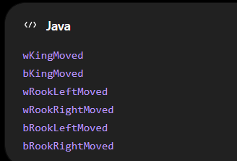
These variables help determine whether castling is still possible.

- En Passant

En passant is a special pawn capture. The program maintains an en passant target position:

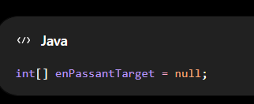
This allows the program to remember the required information after a pawn's two-square movement

- Pawn Promotion
When a pawn reaches the opposite end of the board, it is promoted to another chess piece. In the project implementation, the pawn can be promoted to a queen.
  - Game Flow
START
↓
Initialize Board
↓
Display Chess GUI
↓
Player Selects Piece
↓
Check Player Turn
↓
Find Legal Moves
↓
Highlight Legal Moves
↓
Select Destination
↓
Validate Move
↓
Check King Safety
↓
Is Move Legal?
─────────────┴──────
NO YES
↓ ↓
Reject Move Save Game State
↓ ↓
Select Again Execute Move
↓
Check Special Rules
↓
Change Turn
↓
Check Check/Checkmate
↓
Update Board
↓
Continue Game

  - State Management
The application maintains previous board states so that the player can undo a move.
A stack/deque-based structure is used for storing game states:

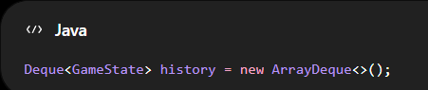

Before executing a move, the current board state and other important game information are stored.

When the user selects Undo, the previous state is retrieved and restored.
State management helps maintain:

- Board position
- Player turn
- Castling status
- En passant information
- Previous game configuration
This allows the game to return to an earlier valid position.

CHAPTER 4
4 . IMPLEMENTATION CODE
import javax.swing.*;
import java.awt.*;
import java.util.ArrayDeque;
import java.util.Deque;

public class ChessGame extends JFrame {

private JButton[][] board = new JButton[8][8];
private String[][] pieces = new String[8][8];

private Deque<GameState> history = new ArrayDeque<>();

private boolean whiteTurn = true;

private int selectedRow = -1;
private int selectedCol = -1;

private JTextArea movesArea = new JTextArea();

// Castling state
private boolean wKingMoved = false;
private boolean bKingMoved = false;

private boolean wRookLeftMoved = false;
private boolean wRookRightMoved = false;

private boolean bRookLeftMoved = false;
private boolean bRookRightMoved = false;

// En passant target square
private int[] enPassantTarget = null;

private int moveNumber = 1;

public ChessGame() {

setTitle("Chess PRO MAX");
setSize(1000, 700);
setDefaultCloseOperation(JFrame.EXIT_ON_CLOSE);
setLayout(new BorderLayout());

initializeBoard();

JPanel boardPanel = new JPanel(new GridLayout(8, 8));

for (int r = 0; r < 8; r++) {

for (int c = 0; c < 8; c++) {

JButton button = new JButton();

button.setFont(new Font("Arial", Font.BOLD, 32));

board[r][c] = button;

int row = r;
int col = c;

button.addActionListener(e -> handleClick(row, col));

boardPanel.add(button);
}
}

JPanel sidePanel = new JPanel(new BorderLayout());

sidePanel.setPreferredSize(new Dimension(250, 700));

movesArea.setEditable(false);
movesArea.setFont(new Font("Monospaced", Font.PLAIN, 14));

sidePanel.add(new JScrollPane(movesArea), BorderLayout.CENTER);

JPanel bottomPanel = new JPanel(new GridLayout(2, 1));

JButton undoButton = new JButton("Undo");

undoButton.addActionListener(e -> undoMove());

JButton drawButton = new JButton("Offer Draw");

drawButton.addActionListener(e ->
JOptionPane.showMessageDialog(
this,
"Draw agreed!"
)
);

bottomPanel.add(undoButton);
bottomPanel.add(drawButton);

sidePanel.add(bottomPanel, BorderLayout.SOUTH);

add(boardPanel, BorderLayout.CENTER);
add(sidePanel, BorderLayout.EAST);

refreshBoard();
}

// ============================================================
// INITIAL BOARD
// ============================================================

private void initializeBoard() {

String[] backRank = {
"R", "N", "B", "Q",
"K", "B", "N", "R"
};

for (int i = 0; i < 8; i++) {

pieces[0][i] = "b" + backRank[i];
pieces[1][i] = "bP";

pieces[6][i] = "wP";
pieces[7][i] = "w" + backRank[i];
}
}

// ============================================================
// HANDLE MOUSE CLICK
// ============================================================

private void handleClick(int r, int c) {

if (selectedRow == -1) {

// Selecting a piece

if (pieces[r][c] != null &&
isCurrentPlayerPiece(pieces[r][c])) {

selectedRow = r;
selectedCol = c;

highlightLegalMoves(r, c);
}

} else {

// Moving selected piece

if (isLegalMove(
selectedRow,
selectedCol,
r,
c)) {

saveState();

String movingPiece =
pieces[selectedRow][selectedCol];

String capturedPiece =
pieces[r][c];

String moveText =
createMoveText(
selectedRow,
selectedCol,
r,
c,
movingPiece,
capturedPiece
);

movePiece(
selectedRow,
selectedCol,
r,
c
);

movesArea.append(
moveNumber +
". " +
(whiteTurn ? "White: " : "Black: ") +
moveText +
"\n"
);

if (!whiteTurn) {
moveNumber++;
}

whiteTurn = !whiteTurn;

checkGameStatus();
}

resetSelection();
refreshBoard();
}
}

// ============================================================
// MOVE PIECE
// ============================================================

private void movePiece(
int sr,
int sc,
int dr,
int dc) {

String piece = pieces[sr][sc];

// En passant capture

if (piece != null &&
piece.endsWith("P") &&
enPassantTarget != null &&
dr == enPassantTarget[0] &&
dc == enPassantTarget[1]) {

pieces[sr][dc] = null;
}

// Castling

if (piece != null &&
piece.endsWith("K") &&
Math.abs(dc - sc) == 2) {

// King side

if (dc == 6) {

pieces[sr][5] = pieces[sr][7];
pieces[sr][7] = null;
}

// Queen side

else if (dc == 2) {

pieces[sr][3] = pieces[sr][0];
pieces[sr][0] = null;
}
}

// Update king movement

if (piece.equals("wK")) {
wKingMoved = true;
}

if (piece.equals("bK")) {
bKingMoved = true;
}

// Update rook movement

if (piece.equals("wR")) {

if (sr == 7 && sc == 0) {
wRookLeftMoved = true;
}

if (sr == 7 && sc == 7) {
wRookRightMoved = true;
}
}

if (piece.equals("bR")) {

if (sr == 0 && sc == 0) {
bRookLeftMoved = true;
}

if (sr == 0 && sc == 7) {
bRookRightMoved = true;
}
}

// En passant target

enPassantTarget = null;

if (piece.endsWith("P") &&
Math.abs(dr - sr) == 2) {

enPassantTarget =
new int[]{
(sr + dr) / 2,
sc
};
}

// Pawn promotion

if (piece.equals("wP") && dr == 0) {

piece = choosePromotion("White");
}

if (piece.equals("bP") && dr == 7) {

piece = choosePromotion("Black");
}

pieces[dr][dc] = piece;
pieces[sr][sc] = null;
}

// ============================================================
// PROMOTION
// ============================================================

private String choosePromotion(String color) {

String[] options = {
"Queen",
"Rook",
"Bishop",
"Knight"
};

int choice = JOptionPane.showOptionDialog(
this,
color + " pawn promotion",
"Pawn Promotion",
JOptionPane.DEFAULT_OPTION,
JOptionPane.INFORMATION_MESSAGE,
null,
options,
options[0]
);

if (choice == 1) {
return color.equals("White") ? "wR" : "bR";
}

if (choice == 2) {
return color.equals("White") ? "wB" : "bB";
}

if (choice == 3) {
return color.equals("White") ? "wN" : "bN";
}

return color.equals("White") ? "wQ" : "bQ";
}

// ============================================================
// LEGAL MOVE
// ============================================================

private boolean isLegalMove(
int sr,
int sc,
int dr,
int dc) {

if (!insideBoard(dr, dc)) {
return false;
}

String piece = pieces[sr][sc];

if (piece == null) {
return false;
}

if (!isCurrentPlayerPiece(piece)) {
return false;
}

// Cannot capture own piece

if (pieces[dr][dc] != null &&
pieces[dr][dc].charAt(0) == piece.charAt(0)) {

return false;
}

if (!validMove(sr, sc, dr, dc)) {
return false;
}

// Save complete state

GameState backup = createState();

// Make temporary move

performMoveWithoutPromotion(sr, sc, dr, dc);

boolean ownKingInCheck =
isInCheck(piece.charAt(0) == 'w');

// Restore state

restoreState(backup);

return !ownKingInCheck;
}

// ============================================================
// BASIC MOVE VALIDATION
// ============================================================

private boolean validMove(
int sr,
int sc,
int dr,
int dc) {

String piece = pieces[sr][sc];

if (piece == null) {
return false;
}

char type = piece.charAt(1);

int rowDiff = dr - sr;
int colDiff = dc - sc;

int absRow = Math.abs(rowDiff);
int absCol = Math.abs(colDiff);

switch (type) {

// ----------------------------------------------------
// PAWN
// ----------------------------------------------------

case 'P':

int direction =
piece.charAt(0) == 'w' ? -1 : 1;

int startRow =
piece.charAt(0) == 'w' ? 6 : 1;

// Move forward

if (colDiff == 0 &&
rowDiff == direction &&
pieces[dr][dc] == null) {

return true;
}

// First two-square move

if (colDiff == 0 &&
sr == startRow &&
rowDiff == 2 * direction &&
pieces[sr + direction][sc] == null &&
pieces[dr][dc] == null) {

return true;
}

// Normal capture

if (absCol == 1 &&
rowDiff == direction &&
pieces[dr][dc] != null &&
pieces[dr][dc].charAt(0)
!= piece.charAt(0)) {

return true;
}

// En passant

if (absCol == 1 &&
rowDiff == direction &&
pieces[dr][dc] == null &&
enPassantTarget != null &&
dr == enPassantTarget[0] &&
dc == enPassantTarget[1]) {

return true;
}

return false;

// ----------------------------------------------------
// KNIGHT
// ----------------------------------------------------

case 'N':

return (absRow == 2 && absCol == 1) ||
(absRow == 1 && absCol == 2);

// ----------------------------------------------------
// BISHOP
// ----------------------------------------------------

case 'B':

return absRow == absCol &&
pathClear(sr, sc, dr, dc);

// ----------------------------------------------------
// ROOK
// ----------------------------------------------------

case 'R':

return (rowDiff == 0 || colDiff == 0) &&
pathClear(sr, sc, dr, dc);

// ----------------------------------------------------
// QUEEN
// ----------------------------------------------------

case 'Q':

return (
(absRow == absCol) ||
(rowDiff == 0) ||
(colDiff == 0)
) &&
pathClear(sr, sc, dr, dc);

// ----------------------------------------------------
// KING
// ----------------------------------------------------

case 'K':

// Normal king movement

if (absRow <= 1 &&
absCol <= 1 &&
(absRow + absCol > 0)) {

return true;
}

// Castling

if (rowDiff == 0 &&
absCol == 2) {

return canCastle(
sr,
sc,
dr,
dc
);
}

return false;
}

return false;
}

// ============================================================
// PATH CLEAR
// ============================================================

private boolean pathClear(
int sr,
int sc,
int dr,
int dc) {

int rowStep =
Integer.compare(dr, sr);

int colStep =
Integer.compare(dc, sc);

int r = sr + rowStep;
int c = sc + colStep;

while (r != dr || c != dc) {

if (pieces[r][c] != null) {
return false;
}

r += rowStep;
c += colStep;
}

return true;
}

// ============================================================
// CASTLING
// ============================================================

private boolean canCastle(
int sr,
int sc,
int dr,
int dc) {

boolean white =
pieces[sr][sc].charAt(0) == 'w';

// Must be king's original position

if (white) {

if (sr != 7 || sc != 4 || wKingMoved) {
return false;
}

} else {

if (sr != 0 || sc != 4 || bKingMoved) {
return false;
}
}

// King cannot castle while in check

if (isInCheck(white)) {
return false;
}

// King side

if (dc == 6) {

if (white) {

if (wRookRightMoved ||
! "wR".equals(pieces[7][7])) {
return false;
}

} else {

if (bRookRightMoved ||
! "bR".equals(pieces[0][7])) {
return false;
}
}

if (pieces[sr][5] != null ||
pieces[sr][6] != null) {
return false;
}

// King cannot pass through check

if (squareUnderAttack(sr, 5, !white) ||
squareUnderAttack(sr, 6, !white)) {
return false;
}

return true;
}

// Queen side

if (dc == 2) {

if (white) {

if (wRookLeftMoved ||
!"wR".equals(pieces[7][0])) {
return false;
}

} else {

if (bRookLeftMoved ||
!"bR".equals(pieces[0][0])) {
return false;
}
}

if (pieces[sr][1] != null ||
pieces[sr][2] != null ||
pieces[sr][3] != null) {
return false;
}

if (squareUnderAttack(sr, 3, !white) ||
squareUnderAttack(sr, 2, !white)) {
return false;
}

return true;
}

return false;
}

// ============================================================
// CHECK
// ============================================================

private boolean isInCheck(boolean white) {

int[] king = findKing(white);

if (king == null) {
return true;
}

return squareUnderAttack(
king[0],
king[1],
!white
);
}

// ============================================================
// FIND KING
// ============================================================

private int[] findKing(boolean white) {

String king =
white ? "wK" : "bK";

for (int r = 0; r < 8; r++) {

for (int c = 0; c < 8; c++) {

if (king.equals(pieces[r][c])) {

return new int[]{r, c};
}
}
}

return null;
}

// ============================================================
// SQUARE UNDER ATTACK
// ============================================================

private boolean squareUnderAttack(
int row,
int col,
boolean byWhite) {

for (int r = 0; r < 8; r++) {

for (int c = 0; c < 8; c++) {

String piece = pieces[r][c];

if (piece == null) {
continue;
}

if ((piece.charAt(0) == 'w') != byWhite) {
continue;
}

char type = piece.charAt(1);

int rowDiff = row - r;
int colDiff = col - c;

int absRow = Math.abs(rowDiff);
int absCol = Math.abs(colDiff);

// Pawn attack

if (type == 'P') {

int direction =
byWhite ? -1 : 1;

if (rowDiff == direction &&
absCol == 1) {
return true;
}
}

// Knight attack

else if (type == 'N') {

if ((absRow == 2 && absCol == 1) ||
(absRow == 1 && absCol == 2)) {

return true;
}
}

// King attack

else if (type == 'K') {

if (absRow <= 1 &&
absCol <= 1 &&
absRow + absCol > 0) {

return true;
}
}

// Bishop / Queen diagonal

else if (type == 'B' || type == 'Q') {

if (absRow == absCol &&
pathClear(r, c, row, col)) {

return true;
}
}

// Rook / Queen straight

if (type == 'R' || type == 'Q') {

if ((rowDiff == 0 || colDiff == 0) &&
pathClear(r, c, row, col)) {

return true;
}
}
}
}

return false;
}

//

CHAPTER 5
- . Graphical User Interface
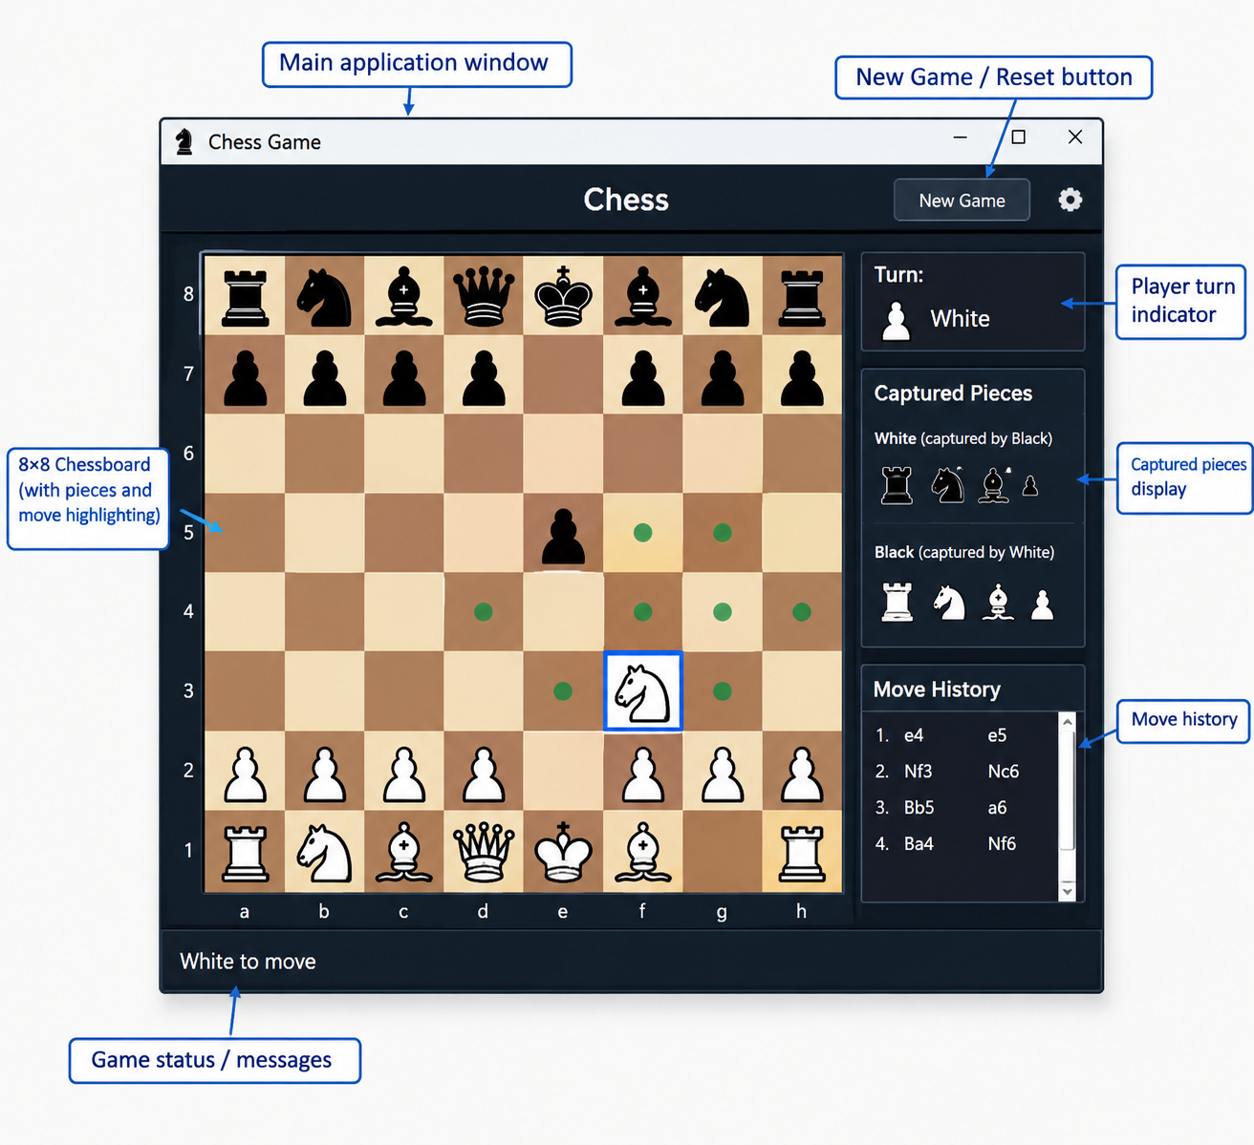
  - GUI Design

- Main Application Window
The main application window is the primary interface of the chess game. It contains all the elements required to play the game, such as the chessboard, player information, captured pieces, move history, and game controls.

2. New Game / Reset Button
The New Game button is used to start a fresh chess match. When pressed, the board is reset to its initial position, all captured pieces are cleared, the move history is removed, and the turn is set back to White.
3. 8×8 Chessboard
The chessboard is the main component of the GUI. It consists of 64 squares arranged in 8 rows and 8 columns. The squares are displayed using alternating light and dark colors. All chess pieces are placed on this board according to the current game position.
4. Player Turn Indicator
This section displays whose turn it currently is. For example, “White” indicates that White must make the next move. After White completes a valid move, the indicator changes to Black.
5. Chess Pieces and Move Highlighting
The chess pieces are displayed directly on the board. When a player selects a piece, its legal possible moves can be highlighted on the board. This helps the player identify valid destinations and prevents confusion during gameplay.
6. Captured Pieces Display
This section shows pieces that have been captured during the game. It can separately display pieces captured from White and Black, allowing players to quickly understand which pieces have been removed from the board.
7. Move History
The move-history panel records the moves made during the current game. For example:
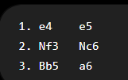
This allows players to review the sequence of moves and understand how the game has progressed
8. Game Status / Messages
The status area displays important information about the current game. Examples include:
- White to move
- Black to move
- Check
- Checkmate
- Invalid move
- Game over
5.2 Features of the Chess Game
- Interactive Gameplay – Allows players to play chess through a graphical interface.
- Legal Move Detection – Automatically identifies and permits only valid moves for each chess piece.
- Turn-Based System – Alternates turns between White and Black players.
- Move Highlighting – Highlights the possible legal moves when a piece is selected.
- Move Validation – Prevents players from making illegal moves.
- Check Detection – Detects when a player's king is under attack.
- Checkmate Detection – Identifies when a player has no legal move to escape check and ends the game.
- Capture Handling – Automatically removes captured pieces from the chessboard and records them.
- Move History – Maintains a record of all moves made during the game.
- Game Reset – Provides a New Game/Reset option to restart the match.
- Game Status Display – Shows messages such as White to Move, Black to Move, Check, Checkmate, and Invalid Move.
- User-Friendly GUI – Provides an organized interface containing the chessboard, controls, turn information, captured pieces, and move history.

CHAPTER 6
6. 6. Results and Discussion
6.1 Result
- Successful implementation of the Chess Game.
- Graphical user interface was developed successfully.
- 8×8 chessboard and chess pieces are displayed correctly.
- Legal and illegal moves are handled correctly.
- Player turns are managed automatically.
- Capturing of chess pieces works correctly.
- Check and checkmate conditions are detected.
- Move history is recorded successfully.
- New Game/Reset functionality works correctly.
6.2 Discussion
- The developed system provides an interactive chess-playing environment.
- The GUI makes the application easy to use.
- The chess rules are implemented and validated through different test cases.
- The system provides immediate feedback for player actions.
- Move validation helps prevent illegal gameplay.
- The application successfully integrates the chess logic with the GUI.
- Testing shows that the major functions operate as expected.
- The system can be further improved with additional features in future versions

CHAPTER 7
7. CONCLUSION AND FUTURE SCOPE
7.1 Conclusion
- The Chess Game application was successfully designed and implemented.
- The project combines chess game logic and graphical user interface.
- The system supports legal piece movements and move validation.
- Player turns, captures, check, and checkmate are handled by the system.
- The GUI provides a simple and interactive environment for playing chess.
- Testing confirms that the major functionalities work as expected.
- The project demonstrates the practical implementation of programming concepts, GUI design, and logical decision-making.
7.3 Future Scope
- AI Opponent: Add an AI player so that users can play against the computer.
- Difficulty Levels: Provide Easy, Medium, and Hard game modes.
- Online Multiplayer: Allow two players to play chess over a network.
- Timer/Chess Clock: Add time controls for both players.
- Save and Load Game: Allow players to save an ongoing game and continue later.
- Undo/Redo: Provide options to undo or redo previous moves.
- Sound Effects: Add sounds for moves, captures, check, and checkmate.
- Player Profiles: Store player names, scores, and game statistics.
- Improved GUI: Add themes, animations, and customizable chessboards.
- Game Database: Store previous games and move records for future analysis.

REFERENCES

- Python Software Foundation, Python 3 Documentation – Tkinter: Python Interface to Tcl/Tk. Available at: Python Tkinter Documentation
- Python Software Foundation, Graphical User Interfaces with Tk, Python Documentation. Available at: Python GUI Documentation
- Fédération Internationale des Échecs (FIDE), FIDE Laws of Chess, 2023. The 2023 Laws came into force on January 1, 2023. Available at: FIDE Laws of Chess
- Niklas Fiekas, python-chess: A Chess Library for Python. Documentation covering chess-board representation, legal move generation, move validation, checkmate detection, and PGN handling. Available at: python-chess Documentation
- Python Software Foundation, Python Programming Language Documentation. Available at: Python Documentation
- David Amos, Python GUI Programming: Your Tkinter Tutorial, Real Python, 2024. Available at: Real Python – Tkinter Tutorial
- python-chess Documentation, Core – Board, Pieces and Squares. Available at: python-chess Core Documentation
- python-chess Documentation, PGN Parsing and Writing. Available at: python-chess PGN Documentation).

